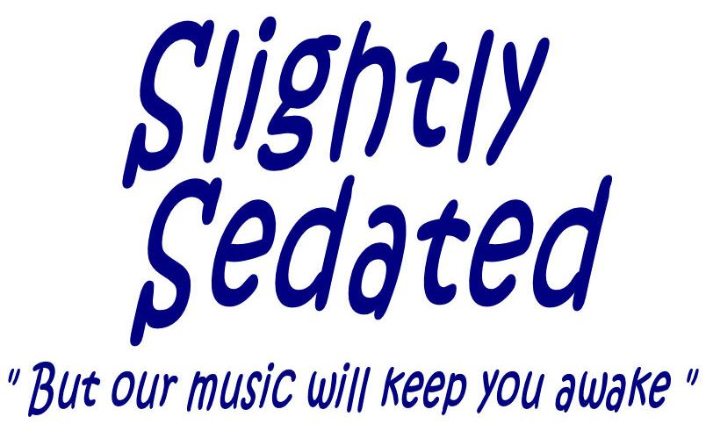
phone: 610-565-0749
email: info@slightlysedated.net
The Band “Slightly Sedated” is available for club work and private parties. As you can see by our philosophy, our repertoire and our business perspective, we’re in this because we’re passionate about our music, about entertaining our fans, and about bringing them back for more. Read on and give us a call if you want to enjoy the experience.
Philosophy – The Slightly Sedated crew has been playing professionally for a long time in a wide variety of bands in the Delaware Valley and this band has logged over 250 shows in the last 15 years. We continue to play and perform because we enjoy it tremendously and we’ve accumulated a significant fan base that looks forward to the fun of our performances. Although many of our songs could be considered “popular”, our overall collection of tunes is anything but. We play to entertain yes, but we play to surprise and to be just a little different.
Repertoire – Our set list is an eclectic mix. Some you’ve heard (and like) and some you’ve never heard (and will). We do classic toe-tappin’, gotta get up and dance, Rock and Blues with harmonies that will bring chills to your spine and just enough comedy to keep a smile on your face. Check out the artists we currently play.
- On the Alt-indie front, we play a generous helping of Black Keys, Green Day, Red Hot Chili Peppers, Cage the Elephant, Lumineers, Sublime, Weezer, Blink 182, Imagine Dragon, and Gorillaz …. these are fun songs and dance oriented. We are very 104.5-ish
- Our Classic Rockin’ Side includes artists such as Tom Petty, Bruce Springsteen, The Eagles, John Mellenkamp, Allman Brothers, The B-52’s, The Rolling Stones, The Ramones & the Talking Heads…. and of course some Beatles.
- Underlying this, we’re built on a Blues foundation of with material by B.B. King, Robert Cray, Dave Mason, Stevie Ray Vaughan, Bill Withers and Van Morrison. On this material, our harmonies will give you goosebumps
- Sprinkled throughout our sets, you’ll find a little Tongue-in-Cheek Comedy to entertain our fans, who generally expect us to be just a little “outrageous”. You won’t find other bands playing Cake, Rehab, Frank Zappa, or David Bromberg….. but we do.
- We also play a batch of Originals that touch the best elements of the above styles (rock, blues, punk, and comedy), and our regulars insist that we mix a few of them in every night.
- …And more … as needed we’ll mix in some Irish Rock/Celtic Punk (Dropkick Murphy’s and Irish Pubs), a little reggae, and of course some Beatles.
Business Perspective – We have a large fan base that has been following us for years and our current email list reaches over 700 people (and growing). Most of these people will see us at least twice a year and many once a month. Our goal is not to over-saturate our fan base and we will generally not play more than twice a month. We understand that our appearances must be profitable for the club owner or we won’t be back. You will find our rates reasonable.
To Book us: Are you interested?? --- WE HOPE SO!!
Just email us at info@slightlysedated.net or call us at 610-453-5853.

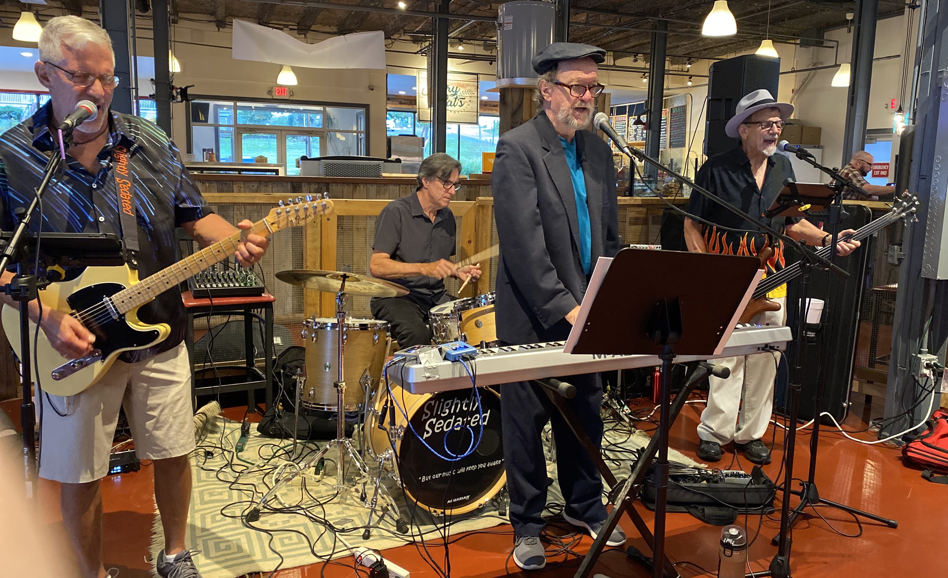

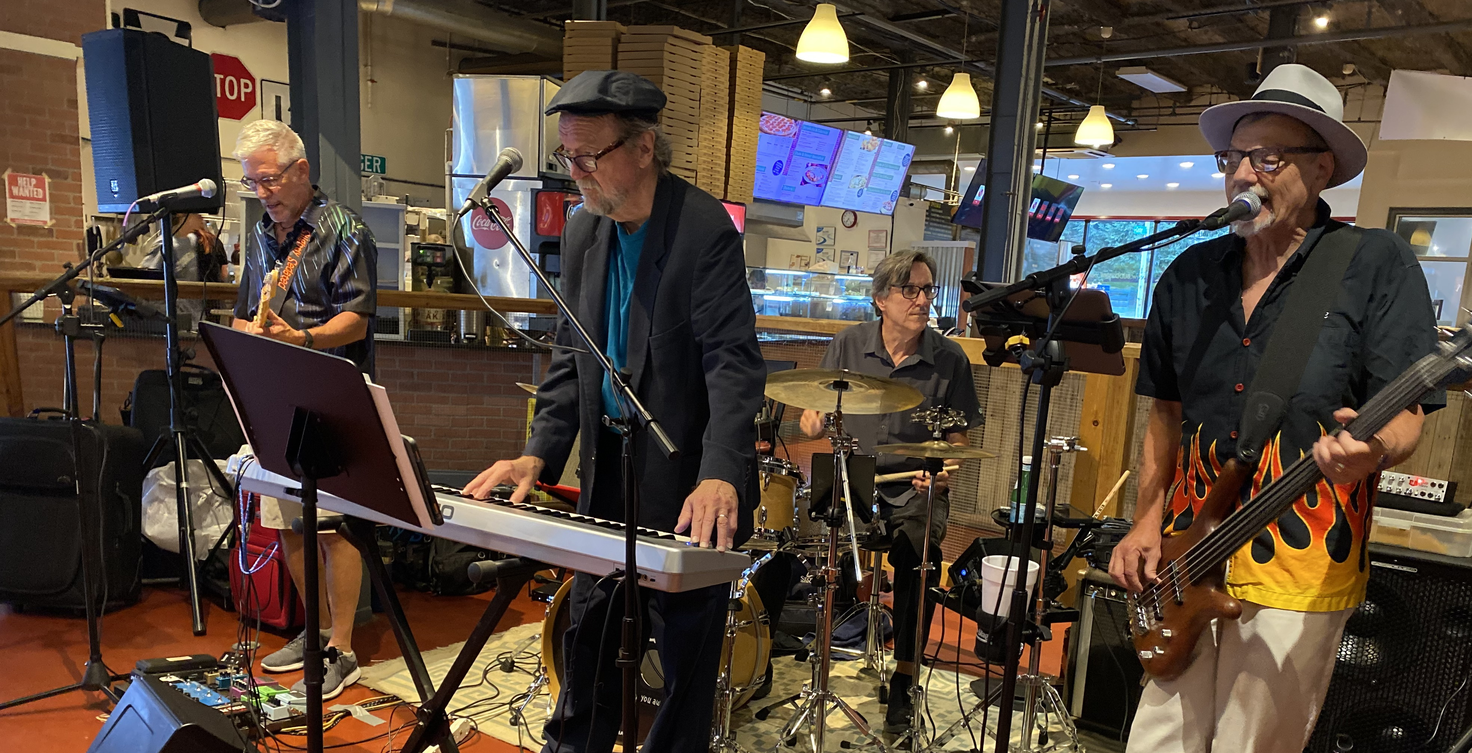
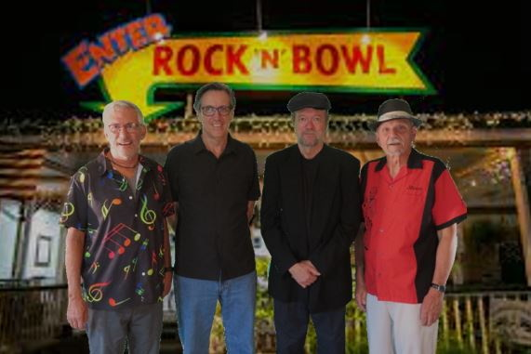

Slightly Sedated Songlist
Title | Artist
Dreadlock Holiday | 10CC
Semi-Charmed Life | 3rd Eye Blind
Please Daddy Don't Get Drunk | Alan Jackson
Santa Claus Wants Some Lovin' | Albert King
Done Somebody Wrong | Allman Brothers
Statesboro Blues | Allman Brothers
One Way Out | Allman Brothers
Whipping Post | Allman, Gregg
Love Shack | B-52's
No Matter What | Badfinger
The Thrill is Gone | BB King
Hard Days Night | Beatles
Back in the USSR | Beatles
Young Blood | Beatles
Honey Don't | Beatles
Money | Beatles
Use Me | Bill Withers
Gold on the Ceiling | Black Keys
Lonely Boy | Black Keys
Wild Child | Black Keys
Dammit | Blink 182
Small Things | Blink 182
I won't be Home for Christmas | Blink 182
Fire Down Below | Bob Seger
Get outta Denver | Bob Seger
Thunder Road | Bruce Springsteen
Trapped | Bruce Springsteen
For What Its Worth | Buffalo Springfield
Ain't No Rest for the Wicked | Cage The Elephant
Back Against The Wall | Cage the Elephant
Never There | Cake
War Pigs | Cake
Short Skirt, Long Jacket | Cake
I'm a Man | Chicago
Johnnie B. Good | Chuck Berry
Son's Gonna Rise | Citizen Cope
It's Your Thing | Cold Grits
Hot Rod Lincoln | Commander Cody
Smoke that Cigarette | Commander Cody
Don't Ever Leave | Counterfit Pennies
Bohemian Like You | Dandy Warhols
Bring it on Home | Dave Mason
Sharon | David Bromberg
Lectric Chair | David Bromberg
Kansas City | David Bromberg
Will Not be Your Fool | David Bromberg
Danger Man | David Bromberg
That's Amore Punk Medley | Dean Martin
Thank You | Dido
Iko Iko | Dr. John
Barroom Hero | Dropkick Murphies
Kiss Me, I'm Shitfaced | Dropkick Murphies
Mr. Grinch | Dweezil Zappa
Galway Girl | Ed Sheeran
Rocket Man | Elton John
My Aim is True | Elvis Costello
After Midnight | Eric Clapton
Learn to Fly | Foo Fighters
Stacys Mom | Fountains of Wayne
Cosmic Debris | Frank Zappa
San Ber'dino | Frank Zappa
Catholic Girls | Frank Zappa
Dog Breath | Frank Zappa
Complicated | Good Charlotte
Seasons | Good Charlotte
Clint Eastwood | Gorillaz
Feel Good Inc. | Gorillaz
Good Lovin' | Grateful Dead
Mexicali Blues | Grateful Dead
Basket Case | Green Day
American Idiot | Green Day
Radioactive | Imagine Dragon
Whiskey in a Jar | Irish Traditional
Flake | Jack Johnson
Bubble Toes | Jack Johnson
Redneck Friend | Jackson Brown
I'm Yours | Jason Mraz
Are You Gonna Be My Girl | Jet
Margueritaville | Jimmy Buffet
Cheeseburger in Paradise | Jimmy Buffet
The Middle | Jimmy Eat World
Feelin' Alright | Joe Cocker
One More Time | Joe Jackson
Little Pink Houses | John Cougar
The Authority Song | John Cougar
Route 66 | John Mayer/N.K. Cole
Please Don't Bury Me | John Prine
Ring of Fire | Johnny Cash
Secret Agent Man | Johnny Rivers
All Day and All of the Night | Kinks
Love Don't Live Here | Lady Antebellum
Whole Lotta Love | Led Zeppelin
Rock'n'Roll | Led Zeppelin
Dixie Chicken | Little Feat
Skin It Back | Little Feat
Sweet Jane | Lou Reed
What a Wonderful World | Louie Armstrong
Willin' | Lowell George
Gimme 3 Steps | Lynyrd Skynrd
Little Bit O’Soul | Music Explosion
Israelites / Quinn | Oysterhead
Me and Julio | Paul Simon
Yellow Ledbetter | Pearl Jam
The One I Love | R.E.M.
I Wanna be Sedated | Ramones
Hey Ho, Let's Go | Ramones
Lobotomy, Wanna Dance | Ramones
Dani California | Red Hot Chili Peppers
Tell Me Baby | Red Hot Chili Peppers
Hump de Bump | Red Hot Chili Peppers
Give It Away | Red Hot Chili Peppers
Bartender | Rehab
Right Next Door | Robert Cray
Gimme Shelter | Rolling Stones
Jumpin Jack Flash | Rolling Stones
Honky Tonk Woman | Rolling Stones
Respectable | Rolling Stones
Can't Get Next to You | Savoy Brown
Slightly Irish Drinking Song | Slightly Sedated
Sedated Boogie | Slightly Sedated
Delco Barbie | Slightly Sedated
Santa Coming to Town/Jingle Bells | Springsteen
Black Friday | Steely Dan
The Galway Girl | Steve Earle
Mary had a Little Lamb | Stevie Ray Vaughn
Red House | Stevie Ray Vaughn
Couldn't Stand the Weather | Stevie Ray Vaughn
House is a Rockin' | Stevie Ray Vaughn
What I Got | Sublime
Santeria | Sublime
Scarlet Begonias | Sublime
Psycho Killer | Talking Heads
The Weight | The Band
Should I Stay or Should I Go | The Clash
Friday I'm in Love | The Cure
Our Lips are Sealed | The Go-Gos
Blood From a Stone | The Hooters
Ho Hey | The Lumineers
Cleopatra | The Lumineers
Cissy Strut | The Meters
I'm a Believer/Clarksville | The Monkees
So Lonely | The Police
Do the things you do/Stir it Up | The Temptations
Behind Blue Eyes | The Who
Dance with Me Tonight | The Wonders
That Thing You Do | The Wonders
Last Dance w/Mary Jane | Tom Petty
Need to Know | Tom Petty
Danny Boy | Traditional
Proper Cup of Coffee | Trout Fishing in Amer
Think we're alone now/Goin' Down | Turtles/Springsteen
Wild Nights | Van Morrison
Brown Eyed Girl | Van Morrison
Mustang Sally | various
Blister in the Sun | Violet Femmes
Beverly Hills | Weezer
I Want You To | Weezer
Pork and Beans | Weezer
El Scorcho | Weezer
Chicken Fried | Zac Brown Band
Sharp Dressed Man | ZZ Top
TV Dinners | ZZ Top

